Capstone Checkpoint 2.1: Agent Design Refinement
Thesis Check: Reasoning Loops, Memory and Tools
Mohit Sachdeva | Agentic AI Program | October 2026
Purpose. Checkpoint 1.1 defined the problem (investors rarely re-test why they own a stock) and a draft multi-agent design. This checkpoint refines that design by deciding where the agent needs a reasoning loop, what it must remember, and which tasks must be handed to tools.
Guiding principle. Use an LLM reasoning loop only where the next step depends on what was just observed; use fixed rules or code where the steps are known in advance. Every addition below targets a specific failure of the prompt-only approach.
1. Design at a glance
The investor gives a ticker and a plain-language thesis. The Thesis Analyst turns it into 3–5 testable claims, which the investor confirms. Two evidence agents gather filing passages and financial data. A Bull and a Bear advocate argue each claim using only that evidence, and a Fact-Checker verifies every number and quote before the Report Writer produces the verdict. The investor approves or overrides it, and the outcome is saved so the same thesis can be re-checked when the next filing arrives. Figure 1 shows the full design.
What changed since Checkpoint 1.1
- Reasoning loops are assigned per agent, not applied everywhere: only the two evidence agents run a full reasoning loop.
- Memory is split into short-term (one check) and long-term (semantic, episodic, procedural), and three agents are deliberately kept free of long-term memory.
- Tools are scoped per agent, and every tool result carries its source.
- Vague theses are handled: the Thesis Analyst asks clarifying questions, and a thesis that still cannot be tested gets a fourth outcome, “Untestable as stated,” instead of a verdict.
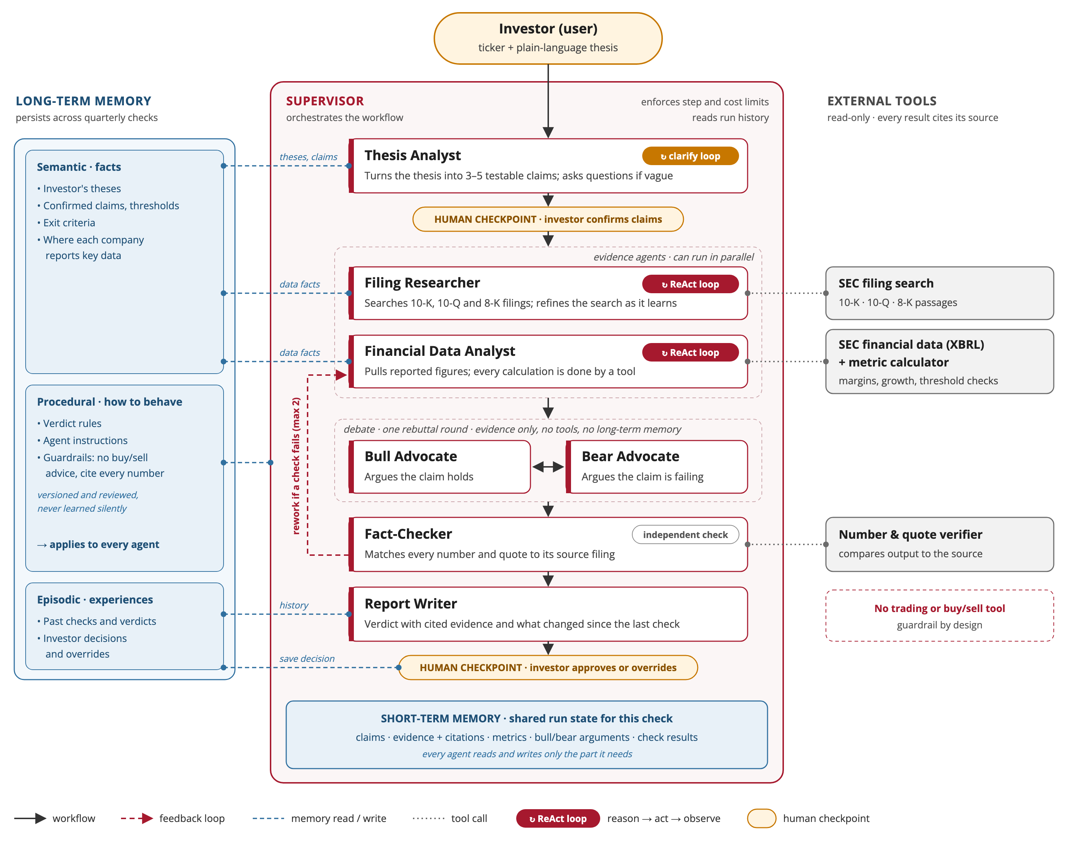
Figure 1. Thesis Check system design: agents, reasoning loops, memory, tools and human checkpoints.
2. Reasoning loop
Thesis Check uses the ReAct pattern (reason → act → observe, then reason again) inside the two agents that hunt for evidence. Their path cannot be scripted in advance: if the latest 10-Q does not explain a drop in margin, the next useful step might be the annual report or an earnings release. Around these agents, the Supervisor runs a fixed sequence of steps with a few bounded feedback loops, so every run is predictable and auditable.
Agent | Reasoning loop? | Why / why not
Supervisor | No. Fixed workflow with rules for looping back | Runs the same sequence every time and enforces step and cost limits. Letting an LLM choose the route would make runs unpredictable and costs hard to bound.
Thesis Analyst | Light. Clarification loop with the investor | Turning a thesis into claims is one structured step. If the thesis is vague, it asks up to 2–3 clarifying questions instead of guessing.
Filing Researcher | Yes. Full ReAct loop | Must search long filings, notice what is missing, and refine its search or switch documents based on what it finds.
Financial Data Analyst | Yes. Short ReAct loop | Companies report figures inconsistently; when one is missing it reasons about an alternative (e.g., derive gross profit from revenue and cost of revenue). All arithmetic is done by tools.
Bull and Bear Advocates | No tool loop. Structured debate | They argue only from gathered evidence, so they cannot introduce unverified facts. One rebuttal round; if more evidence is needed, they ask the Supervisor.
Fact-Checker | No. Rule-based checks | Checking that a number matches its source is a comparison, not a judgment. An LLM is used only to judge whether a passage supports a claim.
Report Writer | No. Single step | Summarizes results that have already been verified.

Example: Filing Researcher testing “gross margin stays above 60%” (illustrative)
Thought: I need the gross-margin trend and management’s explanation.
Action: Search the latest 10-Q for “gross margin.”
Observation: Margin fell this quarter; no explanation is given.
Thought: The reason is probably in the earnings release, not the 10-Q.
Action: Search the latest 8-K earnings release for the margin decline.
Observation: Management cites an inventory charge linked to export restrictions.
Thought: The claim now has a metric and a cited cause. Stop and hand the evidence back.

Bounded feedback loops around the agents
- Human confirmation: the investor confirms or edits the claims before research starts.
- Debate: the Bear challenges the Bull; unresolved disagreement lowers the verdict’s confidence rather than triggering more rounds.
- Verification → rework: a number or quote that does not match its source sends that claim back to the evidence agents, at most twice.
- Stopping rules: every loop has a step limit and a cost budget. When evidence runs out, the claim is marked “insufficient evidence” instead of guessed.
3. Memory
The agent needs both short-term and long-term memory. Short-term memory holds everything produced during a single check, so later steps (debate, verification, the report) build on earlier results without re-fetching them. Long-term memory matters because a thesis is not checked once: it is re-tested every quarter, and the value lies in tracking how each claim changes over time.
Memory type | What it holds | When and why it is needed
Short-term | Claims, evidence passages with citations, computed metrics, bull/bear arguments, check results | During one check. Lets each step use earlier results; cleared after the run and kept only as an audit log.
Long-term: semantic | The investor’s theses, confirmed claims and thresholds, exit criteria; learned data facts (e.g., where a company reports segment margin) | At every new check. The agent re-tests the same claims instead of starting over and avoids repeating past search dead ends.
Long-term: episodic | Past checks: claim results, verdicts, confidence, and the investor’s decisions and overrides | At re-checks and in the report. Shows what changed since the last check (e.g., Intact → Weakening) and improves how claims are drafted.
Long-term: procedural | Verdict rules, agent instructions, guardrails (e.g., never recommend buying or selling) | On every run. Versioned and reviewed by the developer, never learned silently from users.

Agent | Short-term (this check) | Long-term (across checks) | Why
Supervisor | Full run state, step and cost counters | Episodic (read) | Knows when the thesis was last checked and which filings are new.
Thesis Analyst | Thesis, draft claims, investor edits | Semantic + episodic | Reloads confirmed claims; past edits guide how claims are drafted for this investor.
Filing Researcher | Private search notes; writes cited passages | Semantic (data facts) | Remembers where information lives, avoiding repeated dead ends.
Financial Data Analyst | Figures pulled, metrics computed | Semantic (data facts) | Reuses known mappings of how a company labels its line items.
Bull and Bear Advocates | Evidence pack, opponent’s argument | None, by design | Seeing the last verdict would anchor them, recreating the confirmation bias the product exists to counter.
Fact-Checker | Claims, numbers, source text | None, by design | Must stay independent; checking a number never depends on history.
Report Writer | Verified results | Episodic (read) | Writes the “what changed since your last check” section.

Memory design rules
- Scoped views: each agent sees only the part of the run state it needs, which keeps prompts focused and stops agents anchoring on each other’s reasoning.
- Overrides are preferences, not evidence: if an investor keeps overriding negative verdicts, the system must not learn to soften them. The report can point out the pattern instead.
- Filings are not memory: the searchable index of filings is retrieval knowledge, kept separate from what the agent remembers about the investor and past checks.
4. External tools
The LLM reasons and decides what to do next; tools do the work a language model cannot do reliably. Every tool is read-only and returns its result together with its source (filing, section, period), which is what makes verification and the audit trail possible.
Tool | Used by | Limitation it addresses
SEC filing search (10-K, 10-Q, 8-K) | Filing Researcher | Retrieval: knowledge after the model’s training cutoff; documents too long to read in one pass
SEC financial data lookup (XBRL) | Financial Data Analyst | Grounding: exact reported figures instead of remembered or invented ones
Metric calculator (margins, growth, trends, threshold checks) | Financial Data Analyst | Computation: exact arithmetic and comparisons
Number and quote verifier | Fact-Checker | Grounding: confirms every number and quote matches its source
Thesis and run-history store | Supervisor, Thesis Analyst, Report Writer | Memory: keeps theses, claims and decisions across checks

A task where tool use is necessary
Testing the claim “gross margin stays above 60%” requires three things the model cannot do on its own:
- Retrieval: the latest quarterly revenue and cost-of-revenue figures were filed after the model’s training cutoff, so they must be fetched from SEC data.
- Computation: margin and its trend over several quarters must be calculated exactly. An approximate “about 61%” can flip a claim from Met to Broken.
- Grounding: the report may state only numbers the verifier has matched to the source filing.
Tool design choices
- Least privilege: each agent gets only the tools it needs; the Bull and Bear advocates get none.
- Structural guardrail: no trading or buy/sell tool exists, so the system cannot place trades or give recommendations.
- Errors are observations: a tool reports “figure not found; related items available” so the reasoning loop can adapt instead of failing.
- Humans are not a tool: approvals are fixed steps in the workflow that no agent can skip.
5. Improvement over a prompt-only approach
Failure type | Prompt-only behavior | How this design fixes it
Knowledge | Answers from training data that may be months old; cannot read last week’s filing | Retrieval tools fetch the latest primary filings
Computation | States a plausible but invented margin | Figures fetched and computed by tools, then verified
Reasoning | Accepts the investor’s framing and finds reasons to agree | Thesis split into testable claims; the Bear advocate must argue the other side
Verification | Nothing checks the answer before the investor sees it | Fact-Checker validates every number and quote
Consistency | Rewording the question can change the answer | Same claims, data and rules give the same verdict
Continuity | Forgets the thesis by next quarter | Long-term memory re-tests the same claims and reports what changed

Example failure mode: false reassurance from a confident wrong number
Prompt-only. An investor asks a chatbot: “I own this chip stock because AI demand will keep gross margins above 60%. Is my thesis still valid?” The answer agrees that margins “remain strong at around 62%.” The figure comes from training data that predates the latest quarter, and the model, steered by the investor’s framing, looks for supporting reasons. The investor keeps holding, reassured.
Thesis Check. The Financial Data Analyst retrieves the reported figures for the last four quarters and computes margin with a tool, showing it fell to 56% last quarter. The Filing Researcher finds management’s explanation in the earnings release. The Bear advocate puts the decline at the center of its case, and the Fact-Checker confirms every figure against the filing. The verdict is Weakening, each number links to its source, and the investor decides on evidence they can check.
Illustrative scenario; figures are hypothetical.
Trade-off. The added structure costs more time and money per run than a single prompt. That is justified here because one wrong number can drive a costly decision; for simple tasks, such as explaining what gross margin means, a prompt is enough. A later module will measure the difference by running the same test theses through a prompt-only baseline, the course starter agent and Thesis Check, scoring numeric accuracy, citation validity and verdict agreement.
6. Project repository
Repository: github.com/mosachde/agentic-ai-real-world-capstone-work. Version v2.1 adds this Module 2 design refinement: the system diagram, the reasoning-loop, memory and tool decisions, and a log of open design considerations still being refined. The next build step is turning the starter baseline into a single ReAct Filing Researcher connected to SEC data, the first measurable upgrade over the baseline.
This design will continue to be refined as the agent is built and evaluated in later modules.

